Lilly Liu
CURE DIG
1/27/25
Premade Unity GUI Packages Research

Background:
Gui packages are used to create the user interface for unity. While making functional buttons in Unity is not complicated, the graphical aesthetics of buttons is slightly time consuming to do especially in projects with lots of interfaces. Since we don’t have a lot of time, we can use GUI packages as placeholders or as official assets for the user interface.

Access:
GUI packages on unity are available on their asset stores and online. EX: Free 2d GUI Assets https://assetstore.unity.com/listing#cf-ec_category=2d,gui&nf-ec_price_filter=0...0

Types of Packages:
- 2D vs 3D
There are two types of GUI (maybe more) that I could find.
2D GUI and 3D GUI. I think we should use a 2d GUI to simplify the rendering process.

- Free vs Paid
GUI packages can include many many assets so many nice packages require money to use legally. Since we have no budget, we should use only as many free assets as we can.

- Style of GUI
Pre-made GUI packages are designed for many purposes. Some types I saw on the store: Button Backgrounds, Button Text, Item Graphics, Loading Icons, Tool Icons, Inventory, Logos, Scene Backgrounds, Cursors, Fonts, Animations, and more. The packages are designed in many styles from very stylized themed art, to minimalistic flats graphics.

Focus:
The type of GUI I think would be most useful would be free, 2D, and contain as many basic assets that we could need in a minimalistic style. This would allow us to easily create our own assets for missing functions and still be cohesive.

I do think we should also include maybe one paid package for background images, to make the project feel visually only theme and more playful as by being too minimalist will be too far from the objective of branding. Alternatively we could create our own background images to save money.

I have listed some potential packages, but have not decided yet. There’s a lot more but once we pick a style it’ll be easier to pick more in the future.

Potential GUI Packages:

Candidates for UI assets.

- Game Input Assets:
Useful for showing how to use website
https://assetstore.unity.com/packages/2d/gui/icons/game-input-controller-icons-free-285953
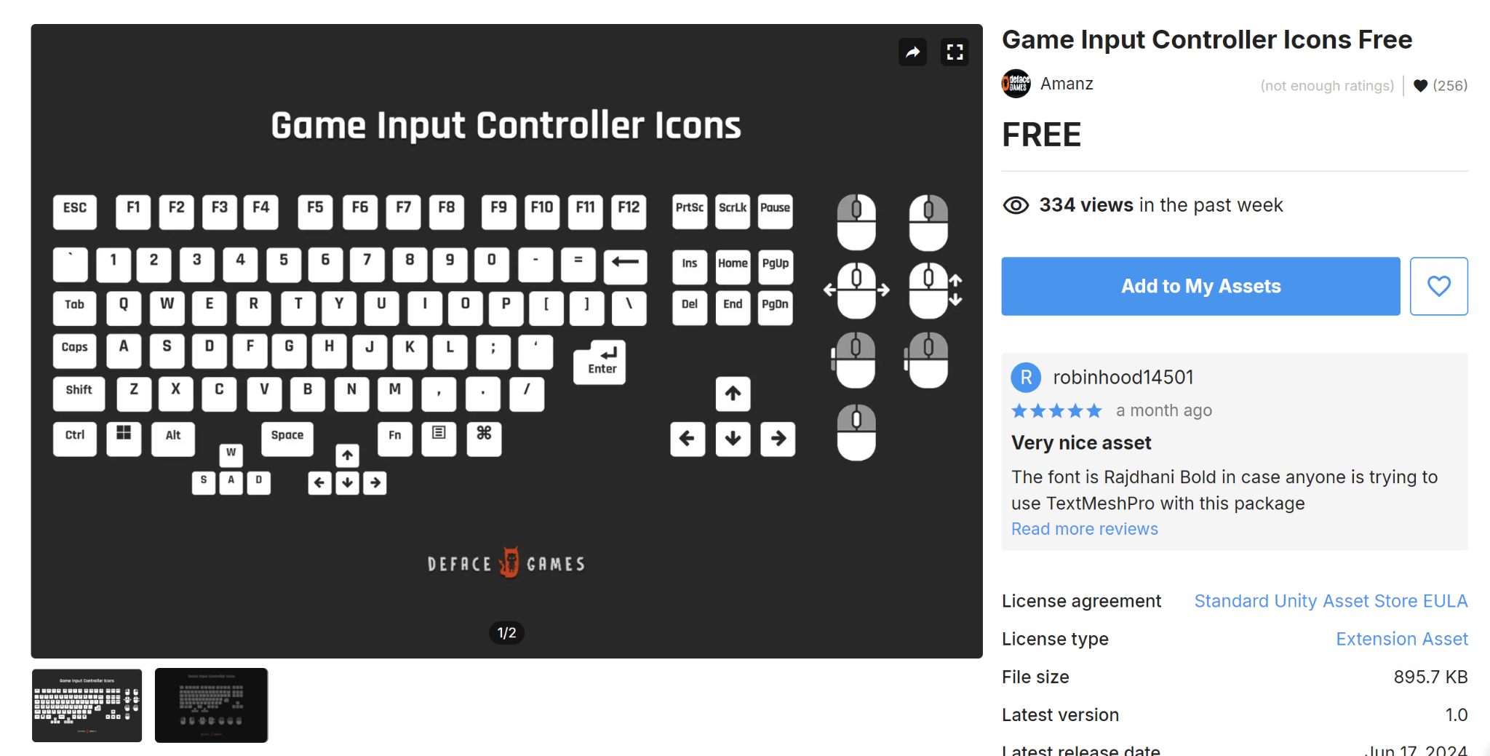

- Low Poly Aesthetic
https://assetstore.unity.com/packages/2d/gui/icons/ui-icons-3d-low-poly-style-244283
This package just includes buttons and window assets, but it also comes with the pressing code and could be readapted easily (I’m guessing). It would match the visuals of the skull and would could help us base the style of the game to be visually retro.
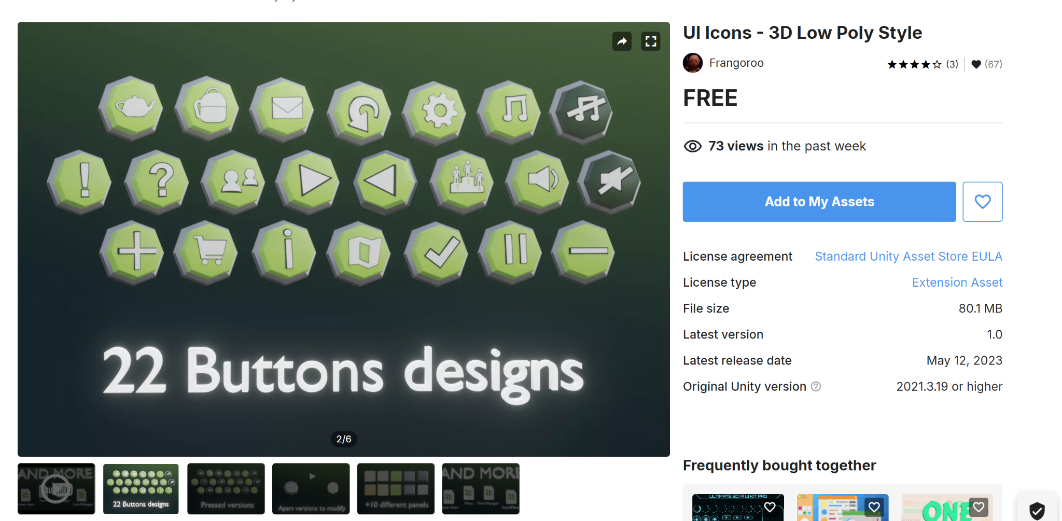

- Wooden Asset Base
https://assetstore.unity.com/packages/2d/gui/fantasy-wooden-gui-free-103811
This is a small GUI package with a style of assets that we could carry over near the end of development when we have free time. This pack has a more rustic aesthetic to it that I think is nice. Limitations: very small and would have to create an extra.
….
Expansion of this Pack that costs money (I don't think we should pay money but could be used as reference to see what we would need to add) https://assetstore.unity.com/packages/2d/gui/fantasy-wooden-gui-package-103817

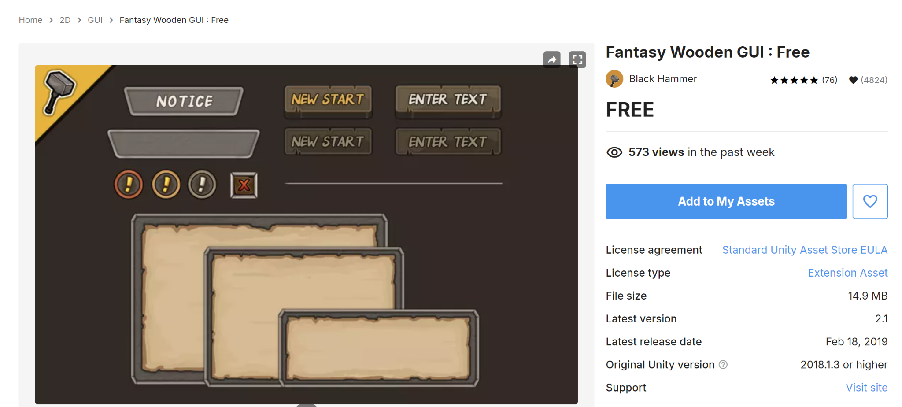

- Low Resolution Icons
https://assetstore.unity.com/packages/2d/gui/icons/a-lot-of-useful-icons-04-127149
Pros: These Icons are made by a creator that has also made several other useful packages with hundreds of useful assets that have these types of icons but in different visual styles.
(There’s 5 version of this useful icon pack)
If we commit to the we don’t care about aesthetics style, we could finish this project a lot easier.
Cons: Low Quality and Aesthetically Questionable for 2024

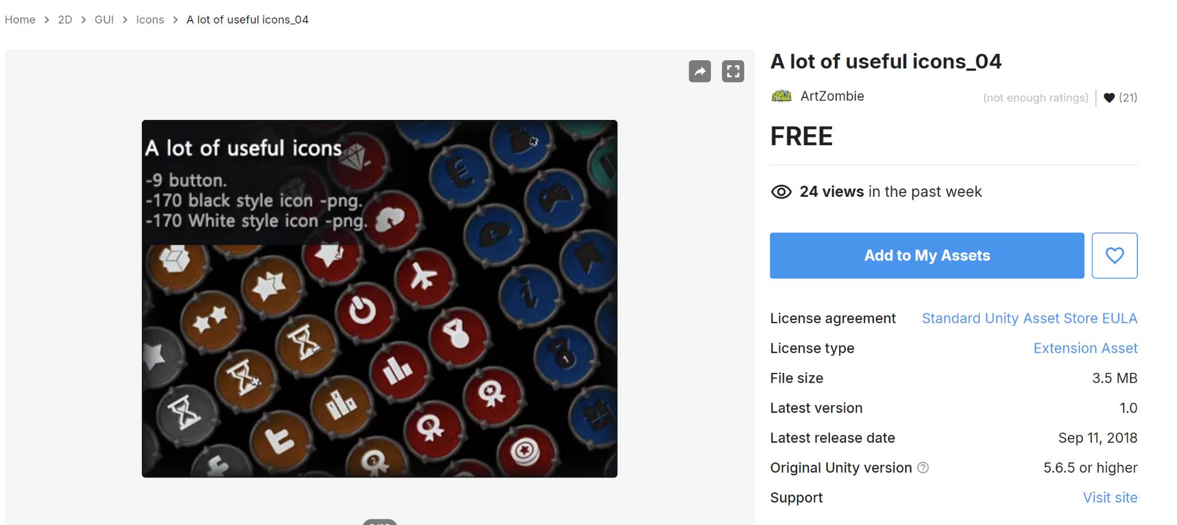

Candidate for background assets.
- Anthropology Lab
I’m imagining this could be used for the start screen, or in the background of the webpage to set a stage for the game of being located in an anthropology lab. We could reduce the poly count and pixel definition significantly and turn excess items into flat images to save on memory. Or use the background to create 2d flat images that load. Or a video that loads.
Alternatively we could create our own “anthropology lab” by taking a 360 video or flat 2D photographs of UF’s Anthropology Lab that we visited.

https://assetstore.unity.com/packages/3d/props/furniture/anthropologist-lab-hdrp-178806

